**IMPORTING GL ACCOUNTS FROM EXCEL**

1. Create import file in excel. Create in excel but then save file as a .csv file before importing.

Make sure the account number column is in text format.

|  |  |  |
| --- | --- | --- |
| 01-1200 | Checking Account | A |
| 01-2000 | Account Payable | L |
| 01-3000 | Retained Earning | C |
| 01-4000 | Box Sales | R |
| 01-5000 | Box Expense | E |
| 01-6000 | Salary Expense | E |

1. Created file should show in the following format in the csv file.

GL Account Number, Account Number Description, Account Type

(A=Asset, L=Liability, C=Capital, R=Revenue, E=Expense)

For example:

1100-00,Checking Account,A

2. Go to: (NR)

Network System Administrator

Run Custom Utility

Type in Util/r-impact.r

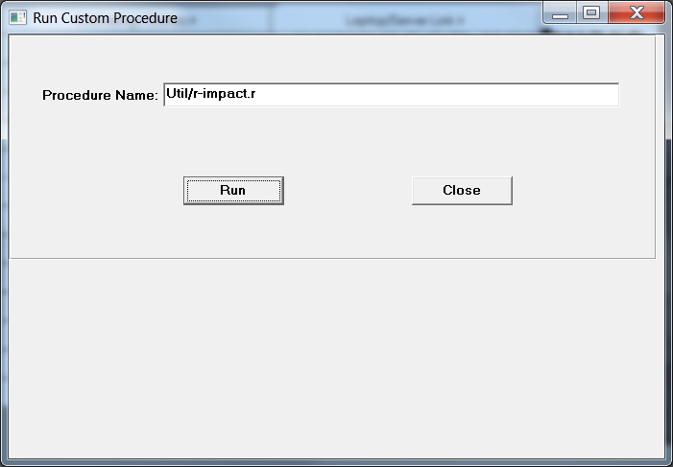

Click Run and then the following screen will pop up. Type in the file path to import file.

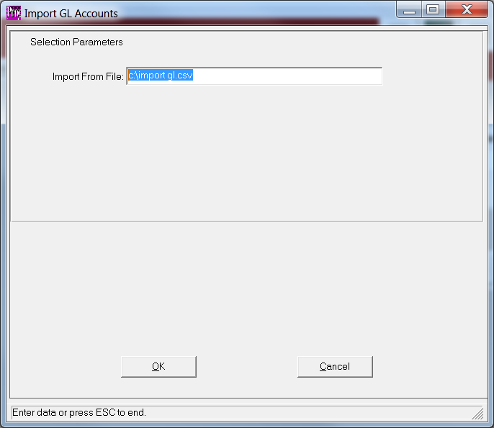

Please note, this does not change the Company File.

Utility will DELETE all existing account numbers for the selected company.

User must manually change the field called GL# Account # of Levels found in the View Company Folder to match the import.

For example, if GL account numbers are 9999-00 format then change level to 2 levels with 4 and 2 for digits per level.

